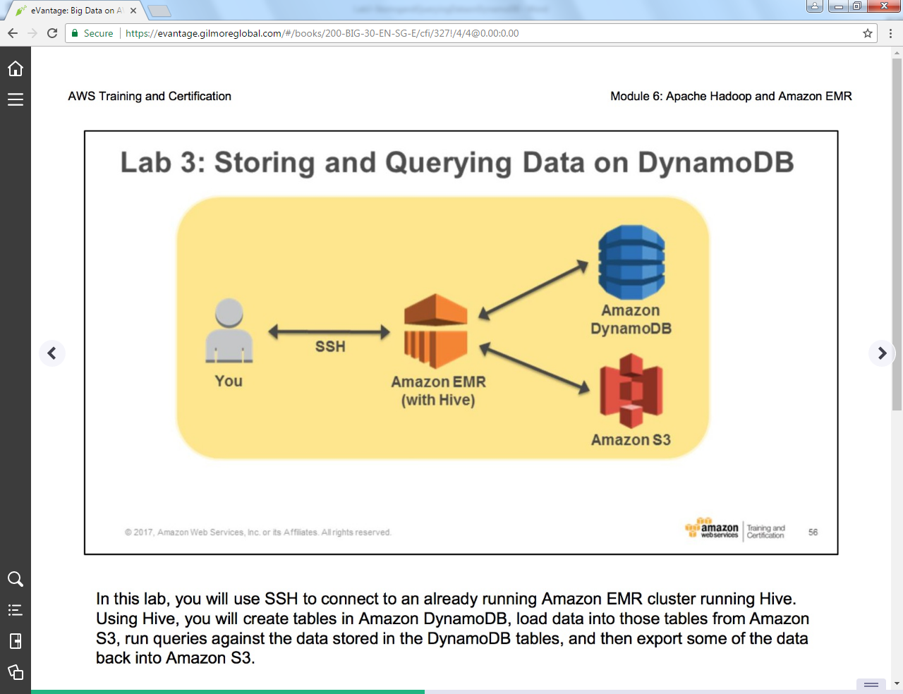

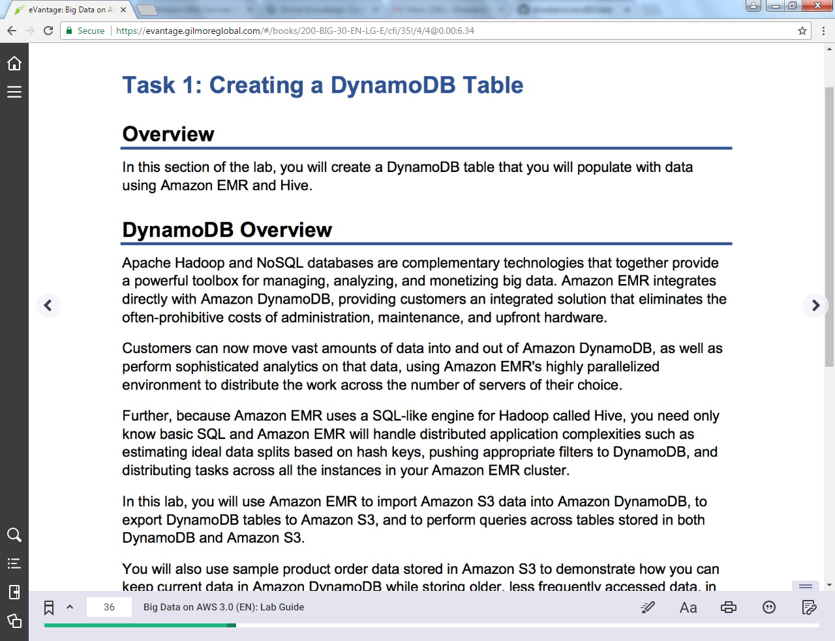

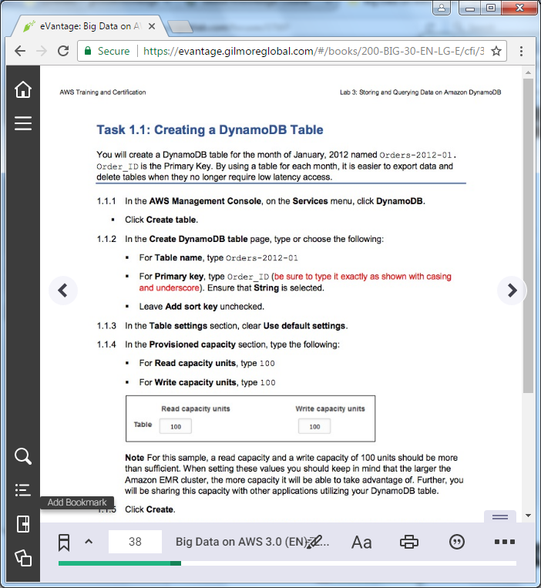

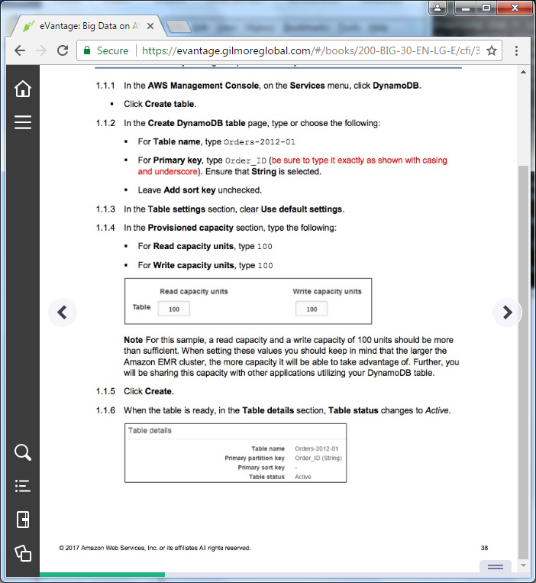

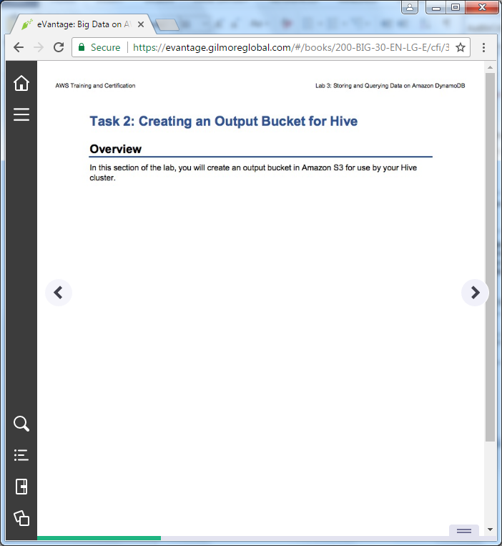

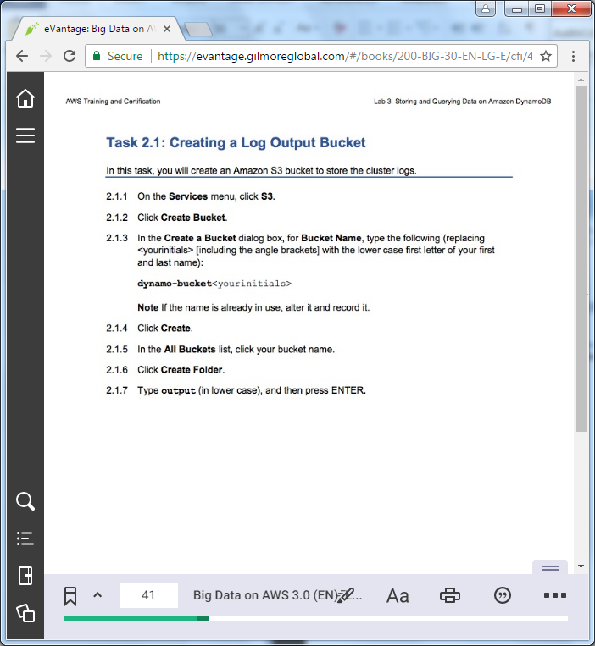

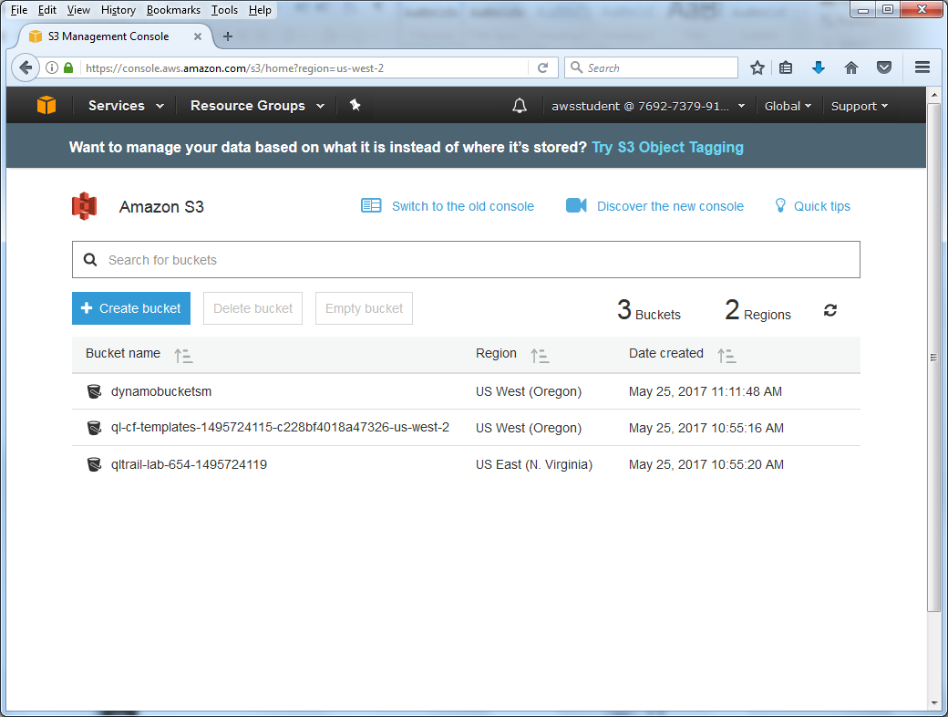

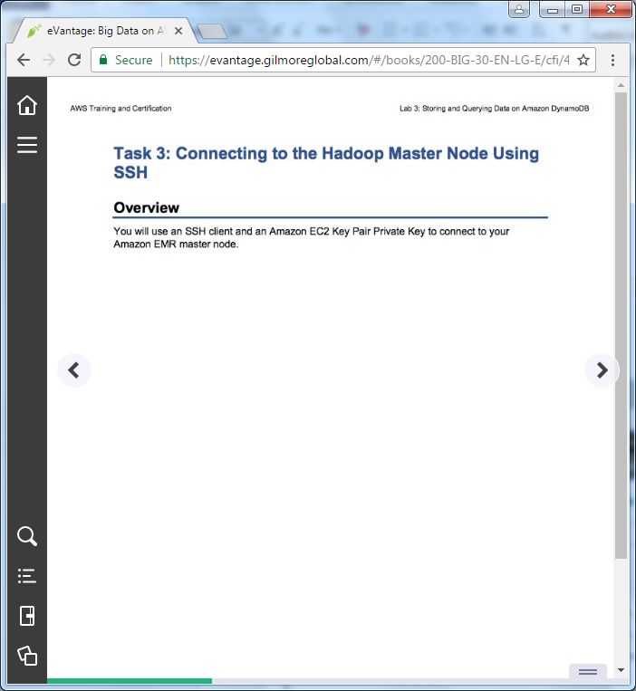

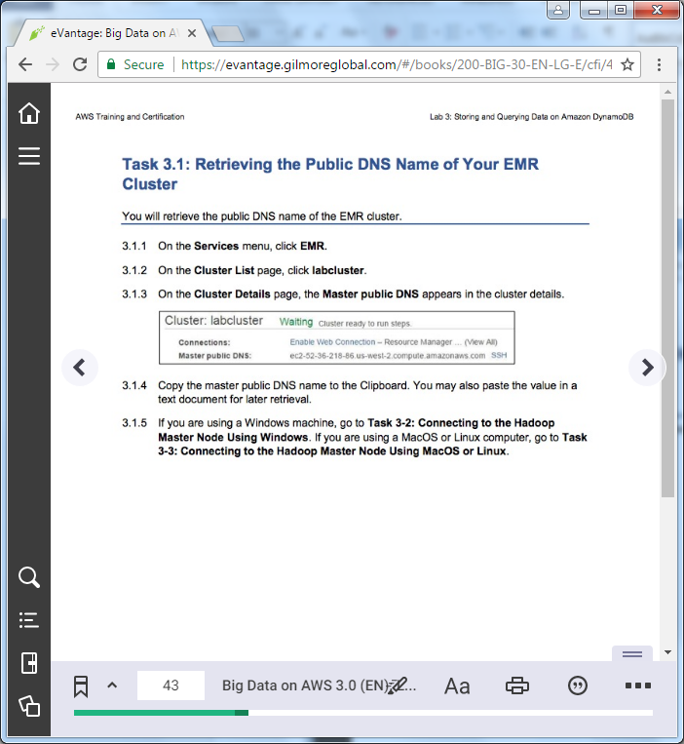

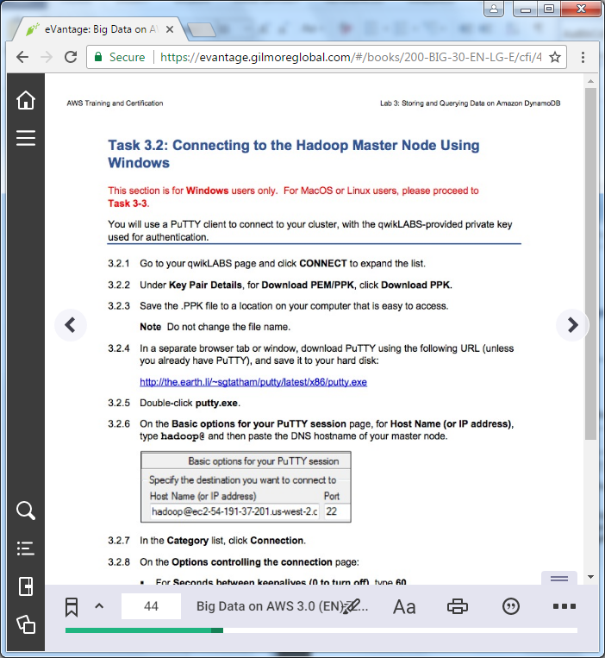

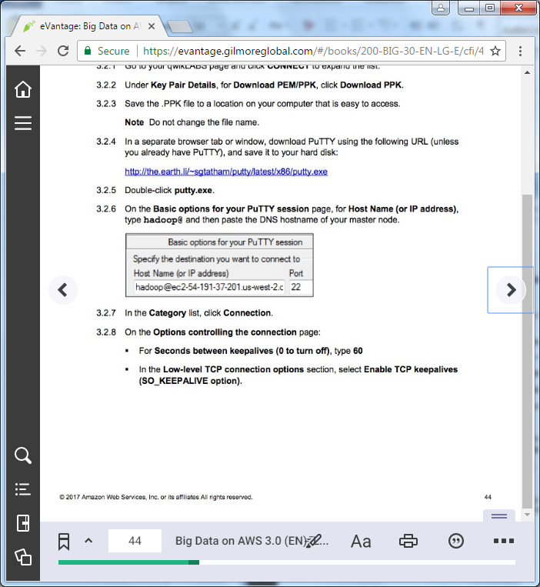

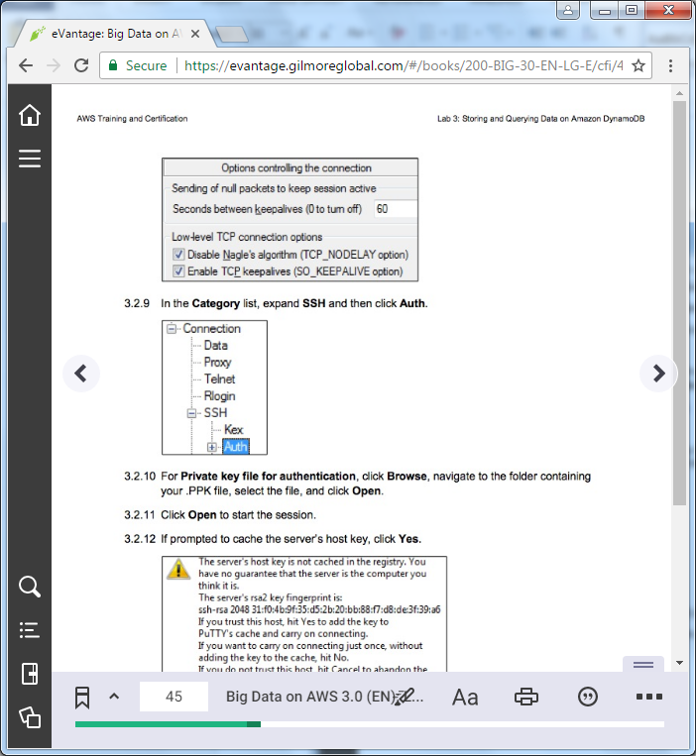

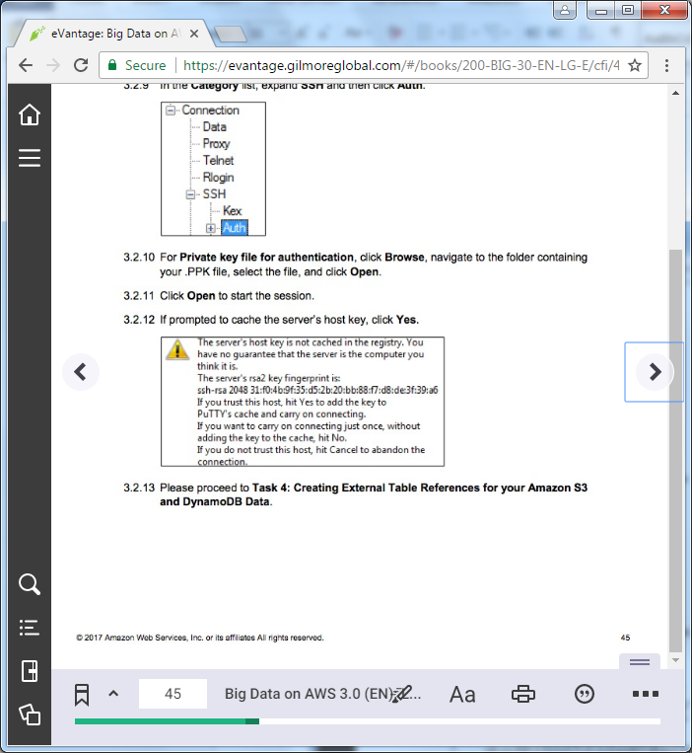

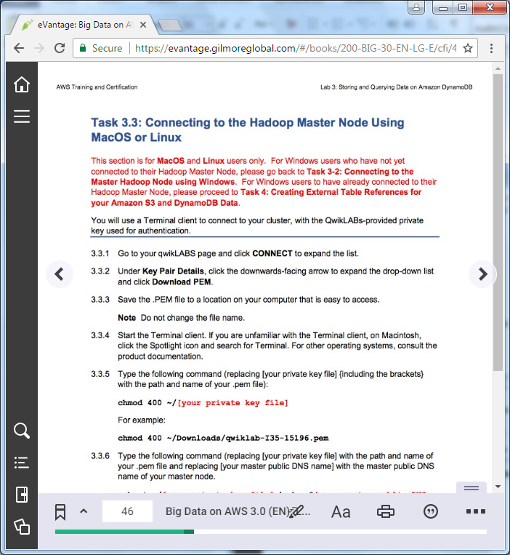

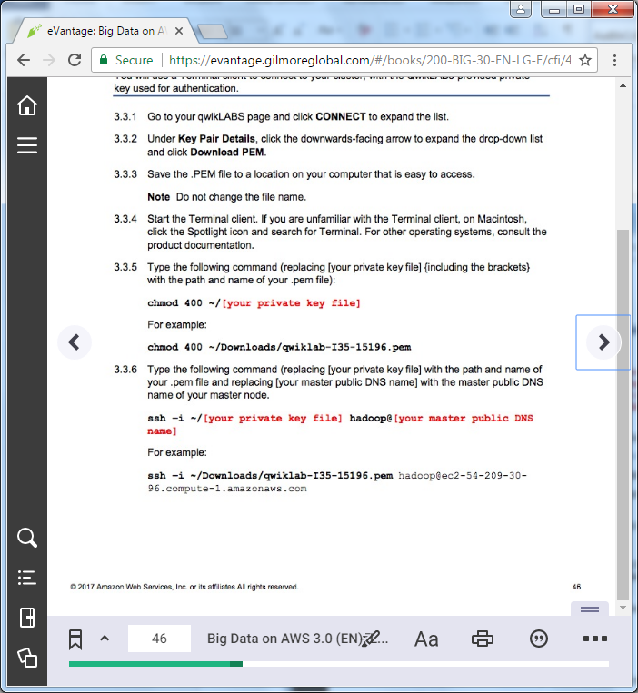

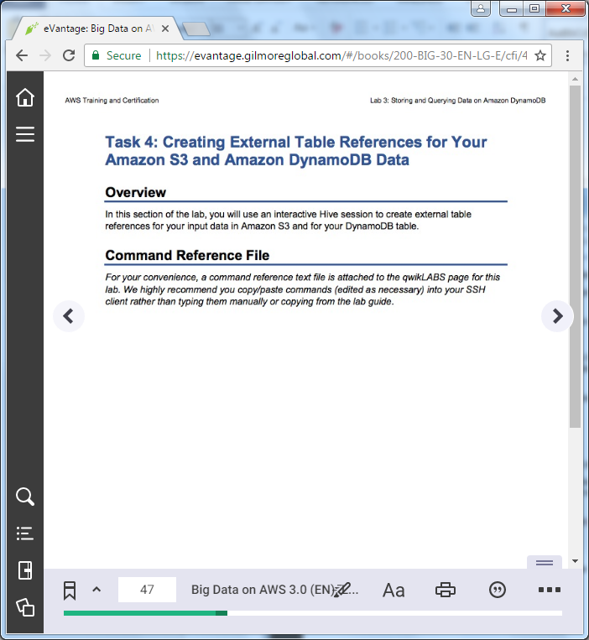

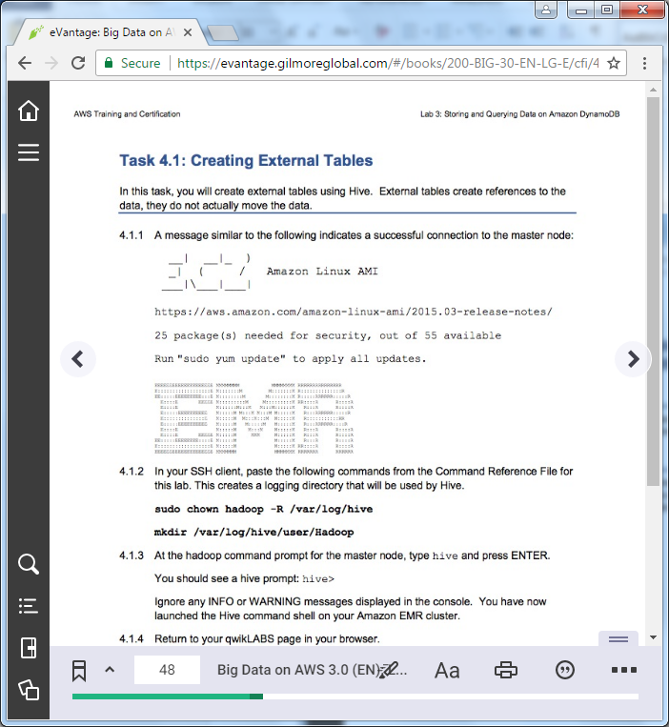

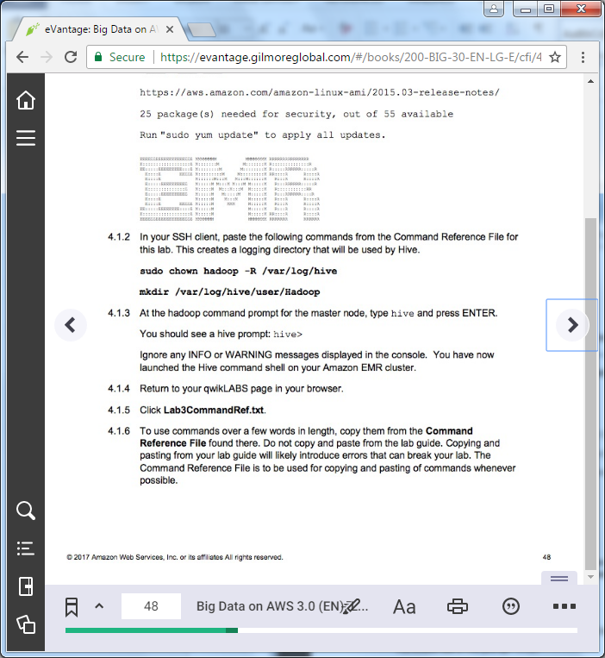

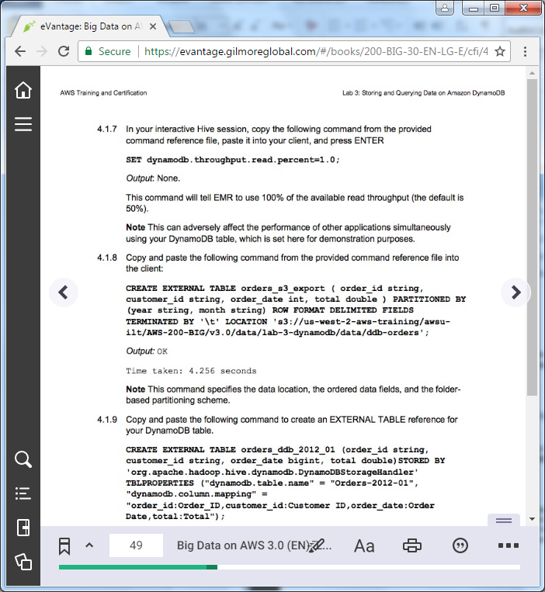

==================================================================================================================

Task 4: Creating External Table References for your Amazon S3 and DynamoDB Data

==================================================================================================================

+++ Step 4.1.2

sudo chown hadoop -R /var/log/hive

mkdir /var/log/hive/user/Hadoop

+++ Step 4.1.7

SET dynamodb.throughput.read.percent=1.0;

+++ Step 4.1.8

CREATE EXTERNAL TABLE orders_s3_export ( order_id string, customer_id string, order_date int, total double ) PARTITIONED BY (year string, month string) ROW FORMAT DELIMITED FIELDS TERMINATED BY '\t' LOCATION 's3://us-west-2-aws-training/awsu-ilt/AWS-200-BIG/v3.0/data/lab-3-dynamodb/data/ddb-orders';

+++ Step 4.1.9

CREATE EXTERNAL TABLE orders_ddb_2012_01 ( order_id string, customer_id string, order_date bigint, total double ) STORED BY 'org.apache.hadoop.hive.dynamodb.DynamoDBStorageHandler' TBLPROPERTIES ("dynamodb.table.name" = "Orders-2012-01", "dynamodb.column.mapping" = "order_id:Order_ID,customer_id:Customer ID,order_date:Order Date,total:Total");

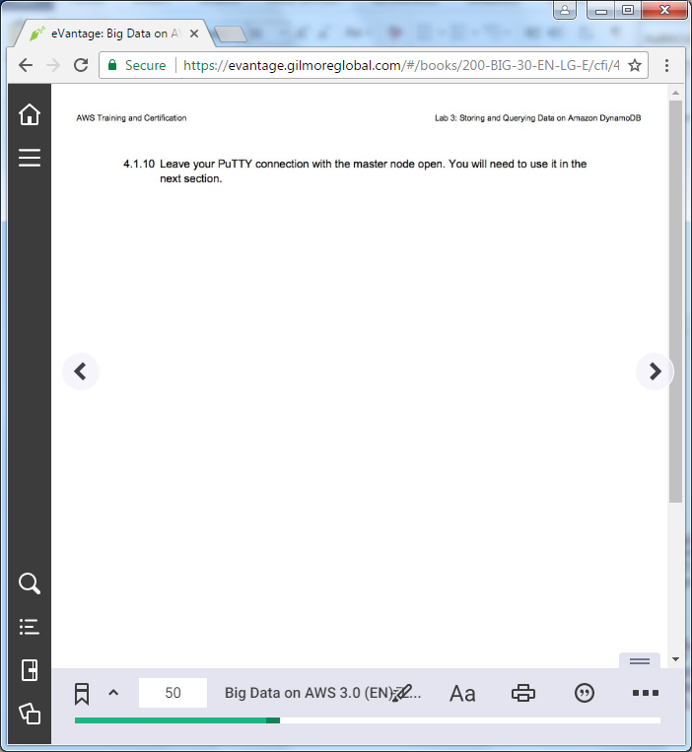

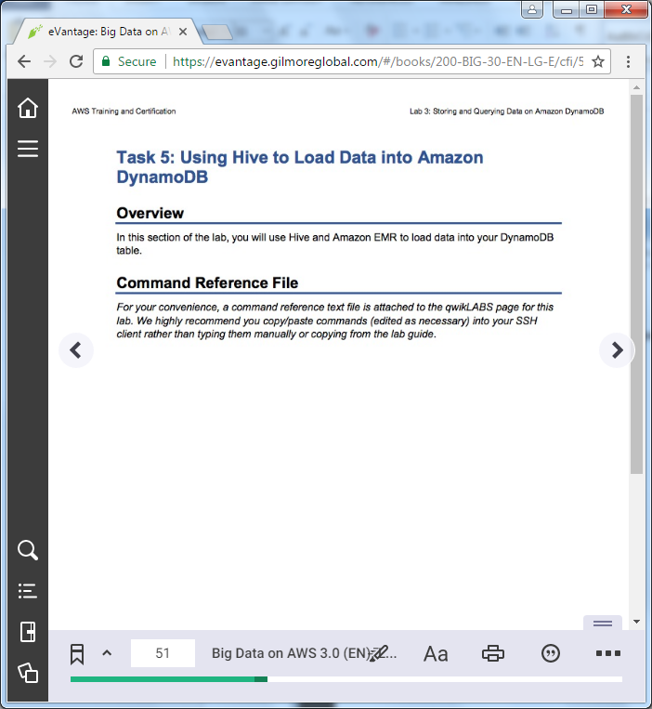

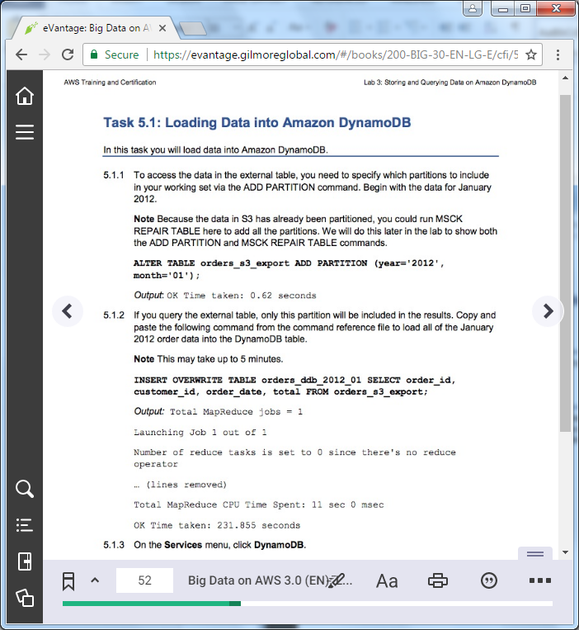

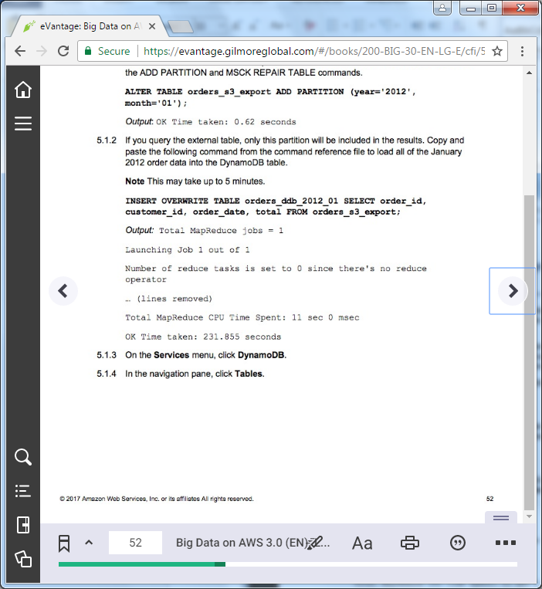

=================================================================================================================

Task 5: Using Hive to Load Data into DynamoDB

==================================================================================================================

+++ Step 5.1.1

ALTER TABLE orders_s3_export ADD PARTITION (year='2012', month='01');

+++ Step 5.1.2

INSERT OVERWRITE TABLE orders_ddb_2012_01 SELECT order_id, customer_id, order_date, total FROM orders_s3_export;

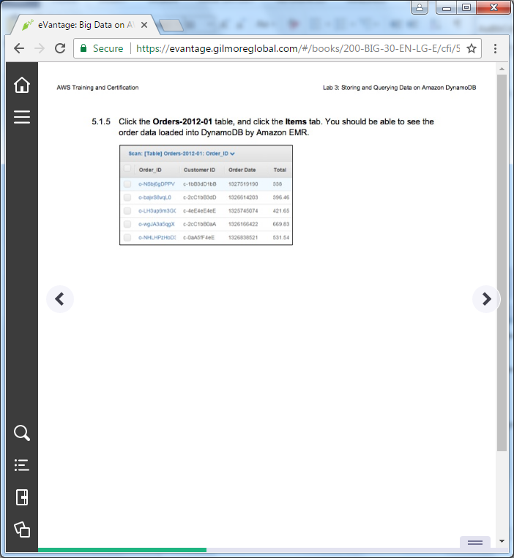

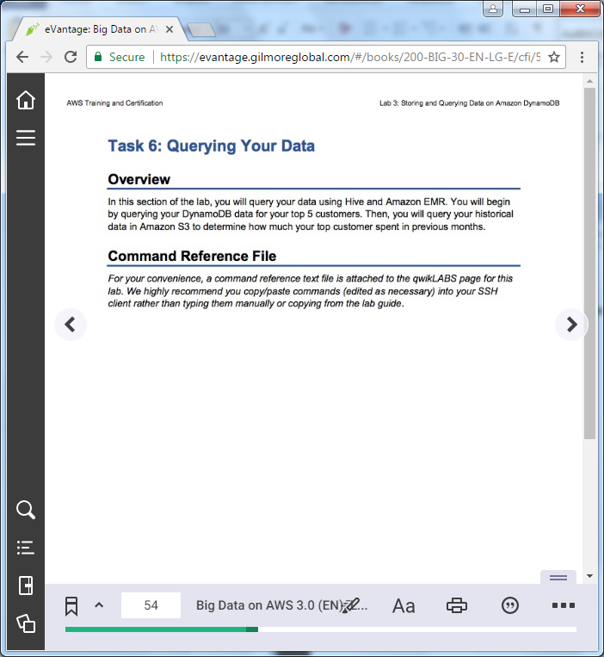

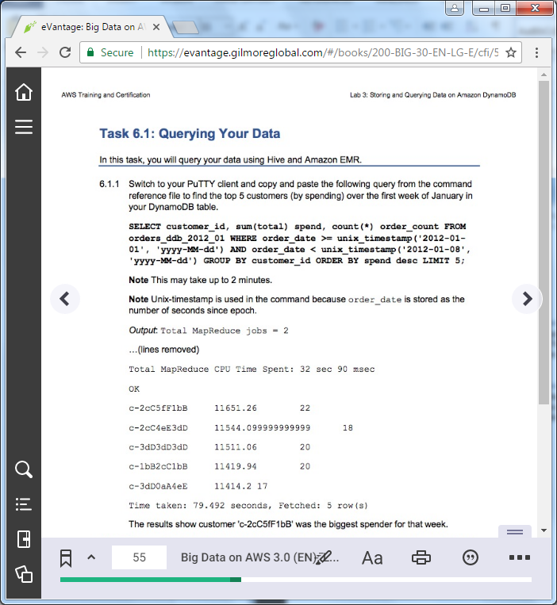

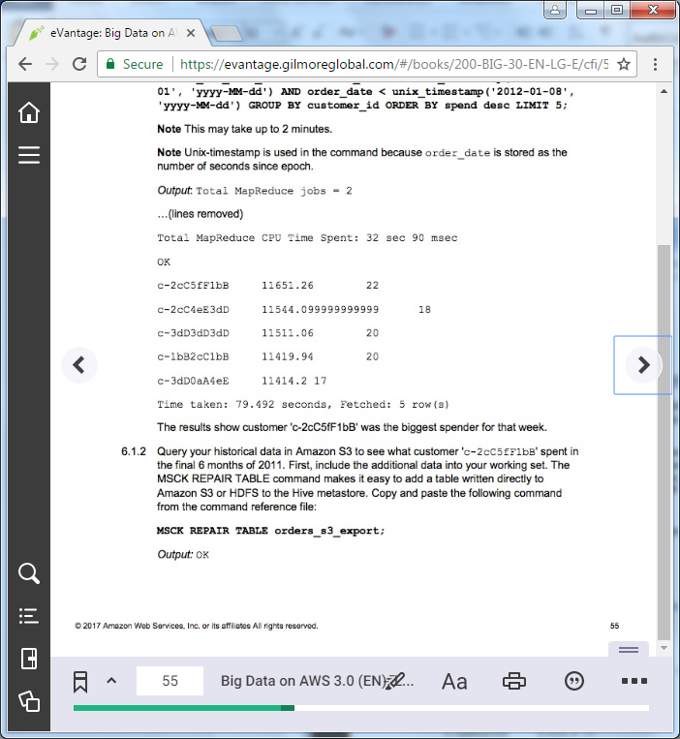

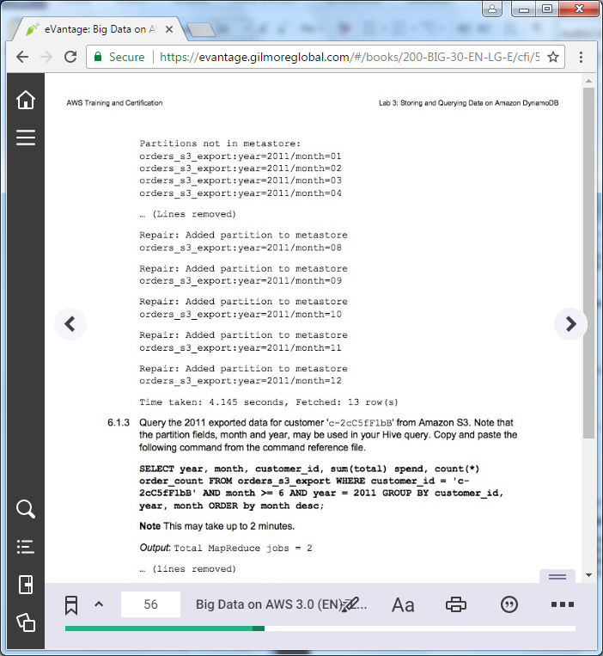

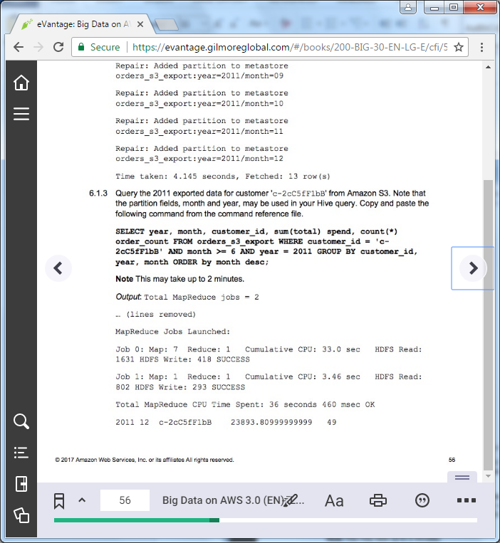

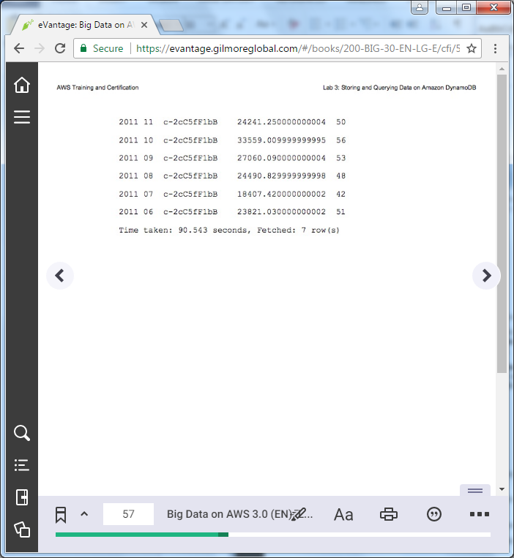

==================================================================================================================

Task 6: Querying Your Data

==================================================================================================================

+++ Step 6.1.1

SELECT customer_id, sum(total) spend, count(*) order_count FROM orders_ddb_2012_01 WHERE order_date >= unix_timestamp('2012-01-01', 'yyyy-MM-dd') AND order_date < unix_timestamp('2012-01-08', 'yyyy-MM-dd') GROUP BY customer_id ORDER BY spend desc LIMIT 5;

+++ Step 6.1.2

MSCK REPAIR TABLE orders_s3_export;

+++ Step 6.1.3

SELECT year, month, customer_id, sum(total) spend, count(*) order_count FROM orders_s3_export WHERE customer_id = 'c-2cC5fF1bB' AND month >= 6 AND year = 2011 GROUP BY customer_id, year, month ORDER by month desc;

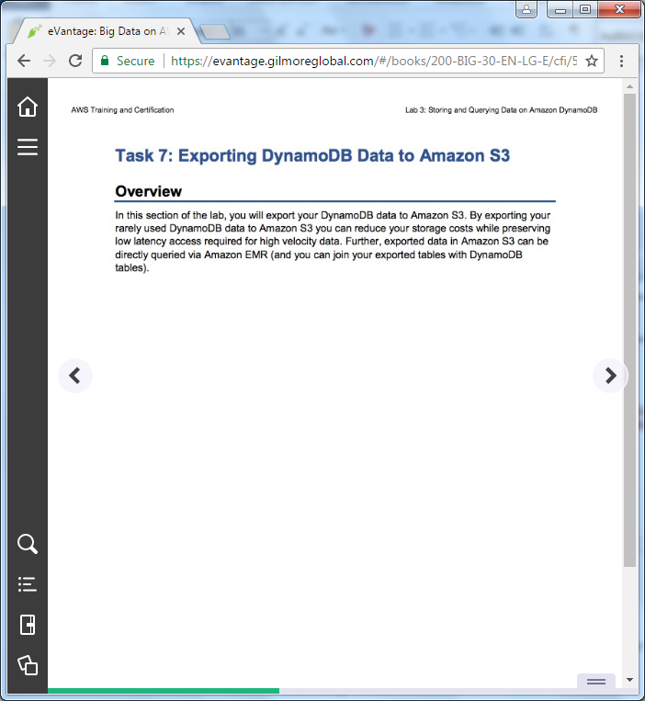

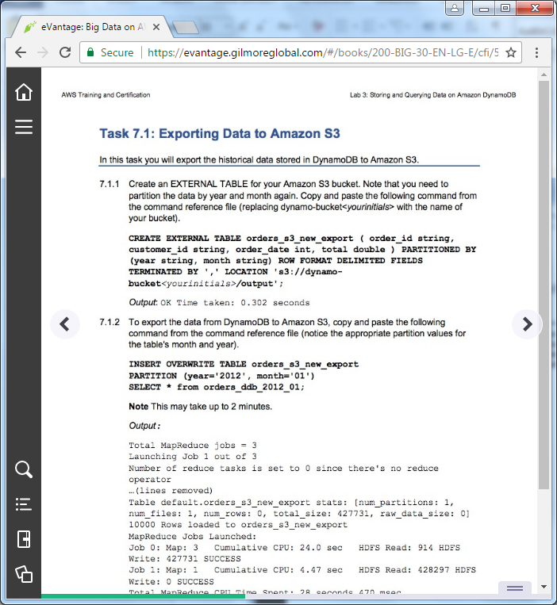

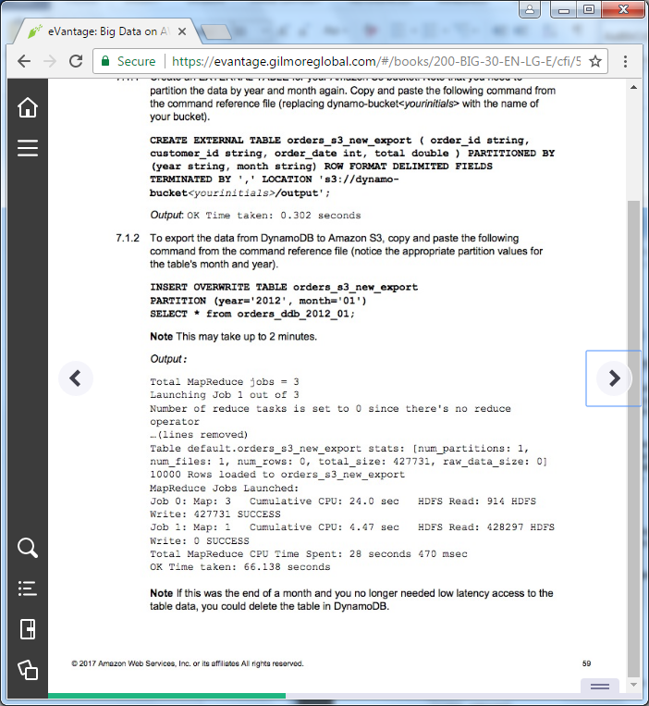

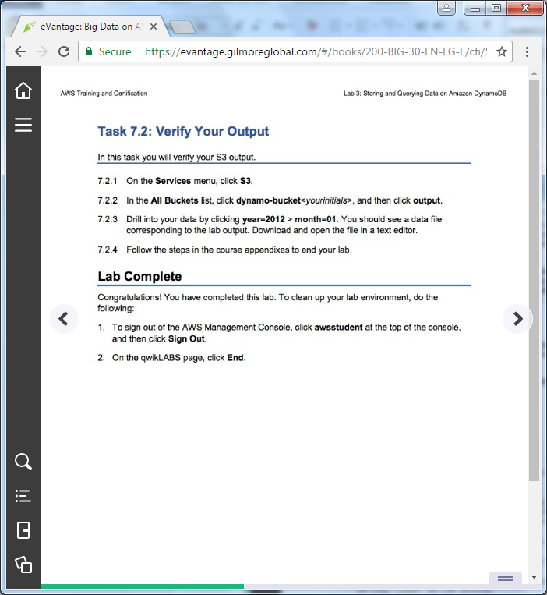

==================================================================================================================

Task 7: Exporting DynamoDB Data to Amazon S3

==================================================================================================================

+++ Step 7.1.1

CREATE EXTERNAL TABLE orders_s3_new_export ( order_id string, customer_id string, order_date int, total double ) PARTITIONED BY (year string, month string) ROW FORMAT DELIMITED FIELDS TERMINATED BY ','LOCATION 's3://dynamo-bucket<yourinitials>/output';

+++ Step 7.1.2

INSERT OVERWRITE TABLE orders_s3_new_export PARTITION (year='2012', month='01') SELECT * from orders_ddb_2012_01;